# Learning Exotic Derivatives without calibration

* Marco Bienchetti & Pietro Rossi, University of Bologna

**Summary**

* Use NN to price option
* Bypass calibration phase : directly learn mapping from implied volatility (or equivalent observed things) and option param (K, T) to prices
* Train by randomization inputs, calling pricer

Proof of concept, only simple models

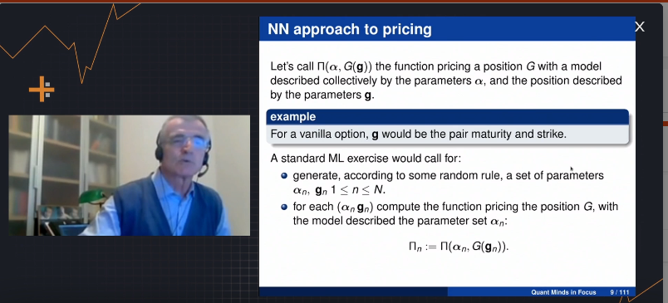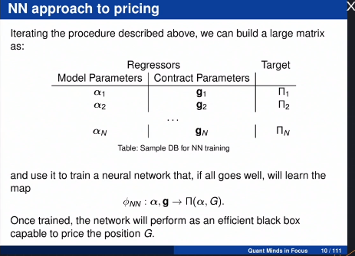

All together :

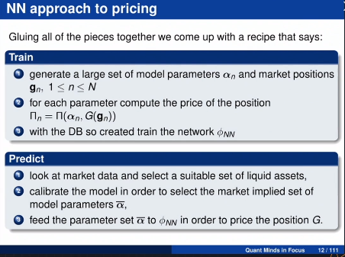

==> High cost on the calibration phase, only okay for simple model (B&S)

**Modification : Market Map**

Calibration : find a map, from market implied volatility to model parameters

Instead with : go directly from market implied volatility to prices

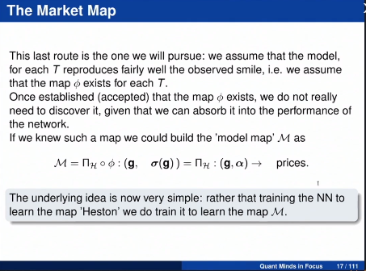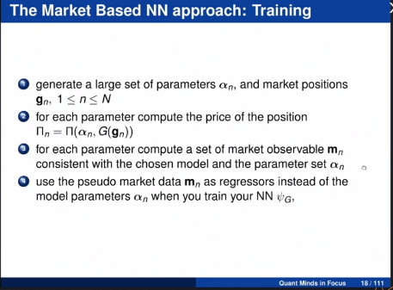

Example Heston, European Options

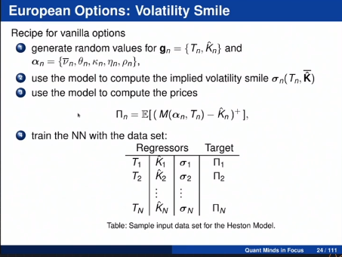

How to choose random distribution ? :

* Uniform distributions
* Careful on boundaries
* …

=> Large variety of shape

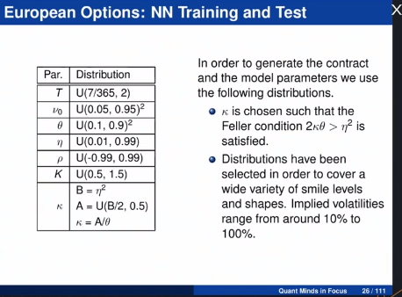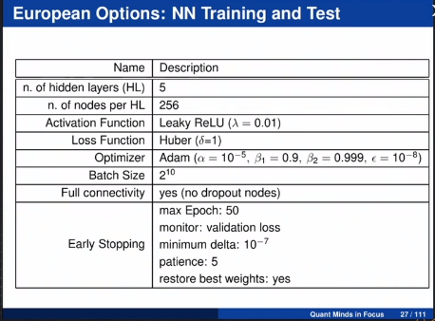

(Huber loss, 5 Hidden, 10**7 training set, 10**6 test set)

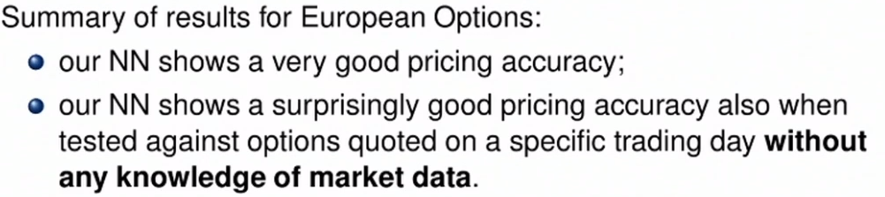

Other test : On Knock-Out option accuracy of NN comparable with accuracy of MC with 1 Millions simulations

Conclusion

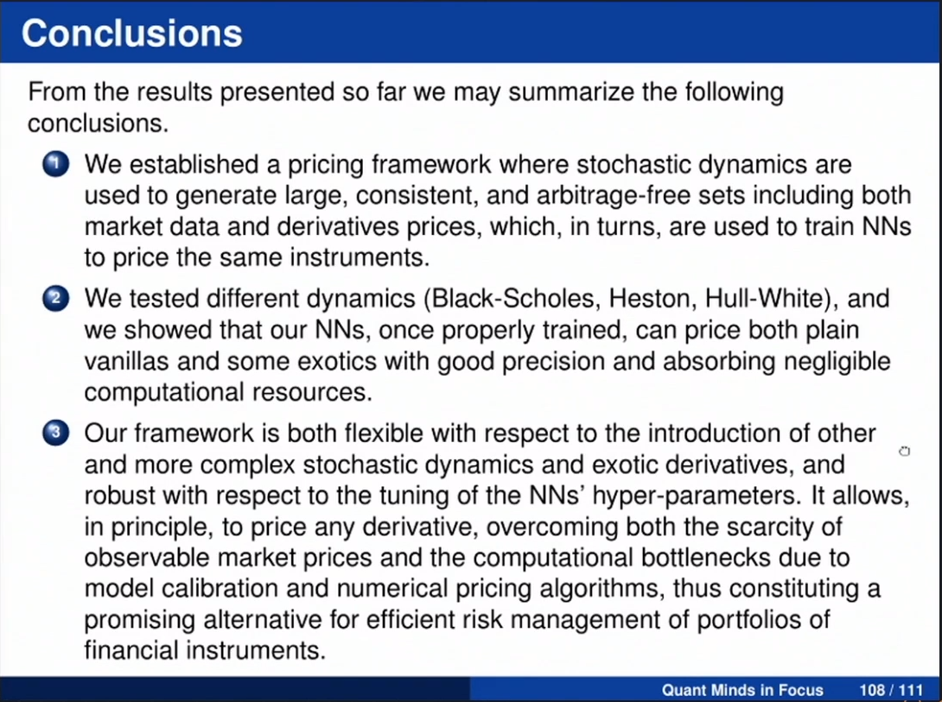

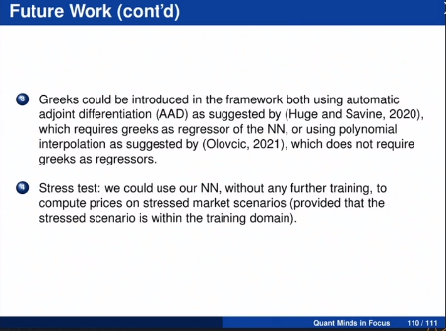

Note Lionel : je comprend pas trop le but final … vu qu’on a pas les params du modèle on peut pas repricer autre chose.

Ne parle pas des biais

# Pricing Bermudan Swaptions with Supervised Learning Algorithms

* Riccardo Aiolfi
* Nicola Moreni

<https://arxiv.org/abs/2105.00655>

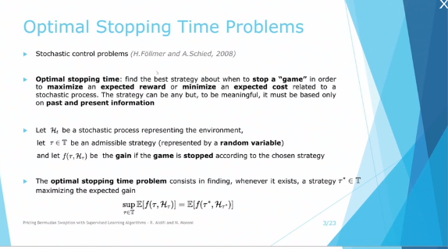

Example in Finance : Pricing of Bermudan option

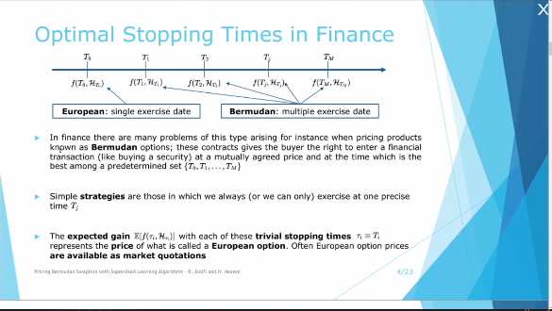

* European Option <= Bermudean (because we can always decide to stop at a predetermined time)
* The more european option are ‘uncorrelated’ the higher the price of bermudean
* European option = natural hedge of bermudan

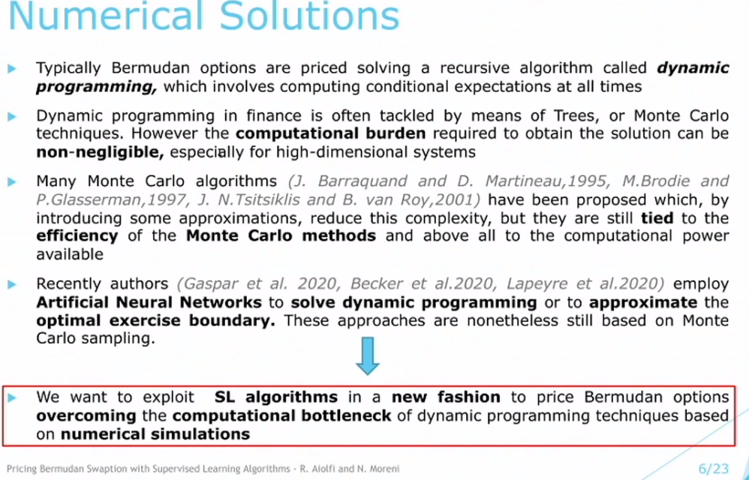

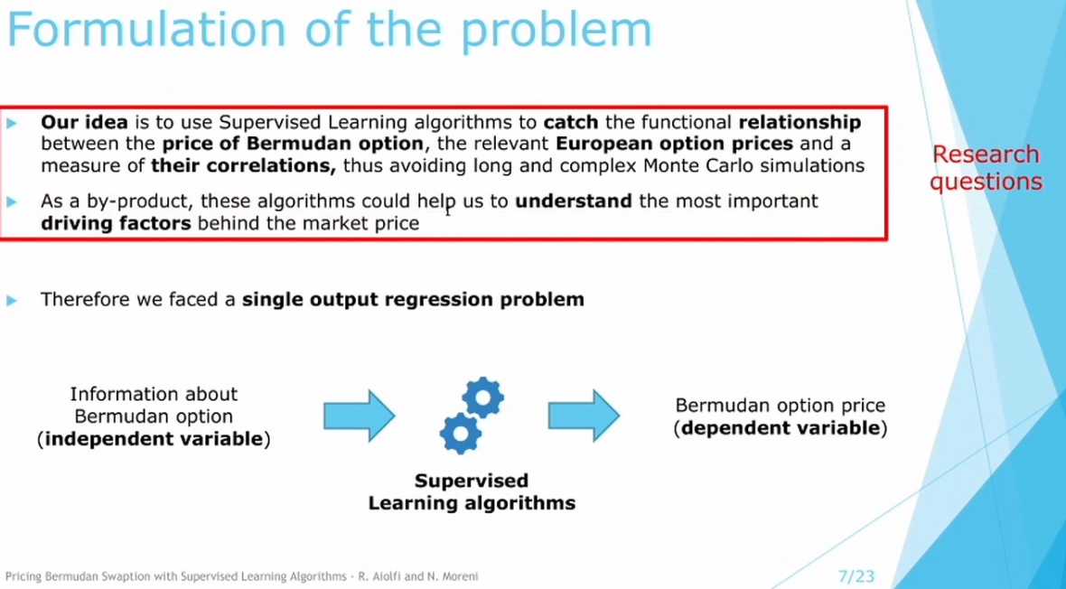

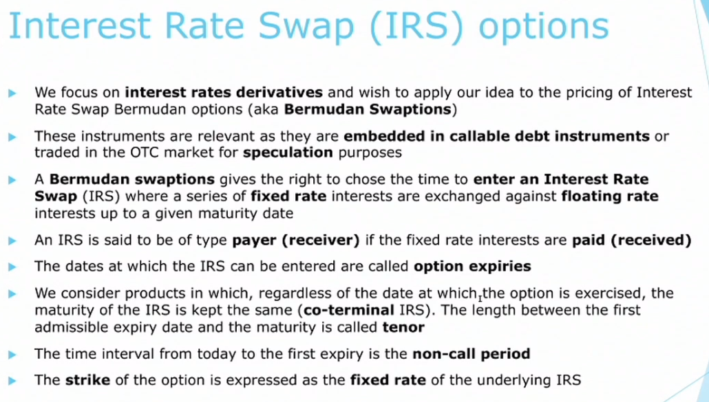

**=> in vitro dataset : more variability of independant variables**

**Dataset I :**

4340 bernuda swaption, 10 pair of parameters (mean reversion, vol) x 434 swaption (tenor; strike, …)

Features :

* Tenor, Strike, Side, Non-call period
* Correlation between swap rates
* Maximum underlying European swaption (using pricer)

Target = Bermudan price

Algo :

* KNN, Linear Model, SVM
* Tree, RF, Gradient Boosting
* NN

Overview :

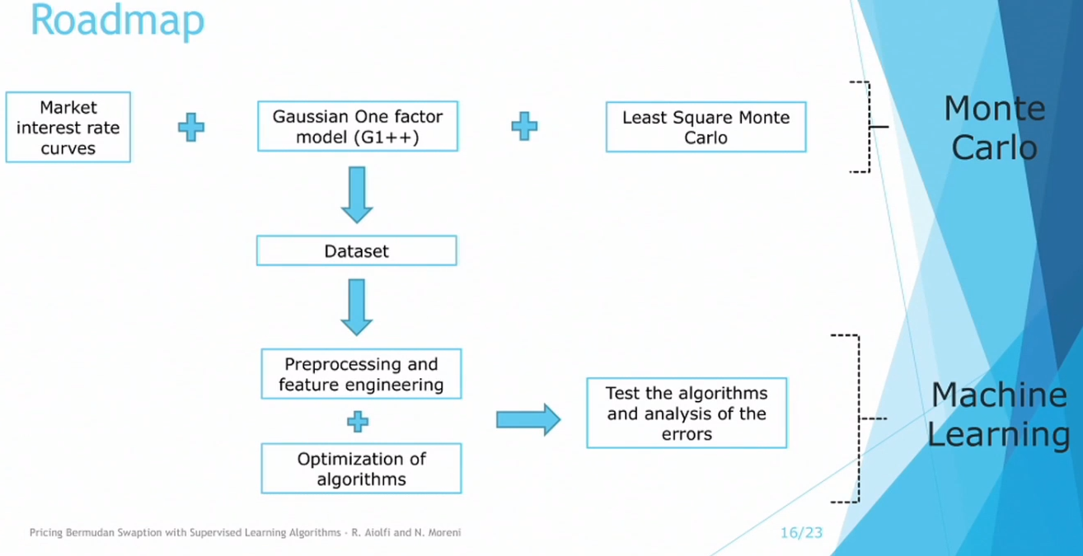

=> Ridge best, GBoosting and NN good also.

Feature importance : Max Value of European (which is lower bound)

Natural Language PRocessing ESG Inishgts for Quantitative Investiment

* [www.sesamm.com](http://www.sesamm.com)

NLP, usage of embedding and similarity to asset link between article and

* Entity
* Theme
* …

Data from Txt is sometimes/usually “more timely”

Modularity on what indicator you want (especially using embedding : no re-training needed)

Example : predict quantile of volatility (to construct low vol portfolio)

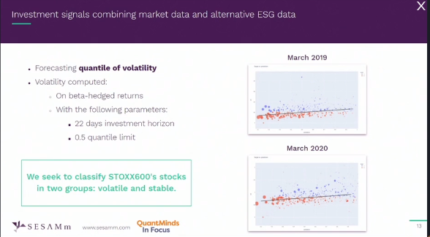

Focus on simple model, explainable, easy to understand.... (and also avoid overfitting)

Dimension reduction

=> selected pipeline : PCA + Logit (easy and simple) :

“most of performance comes from data and not from model”

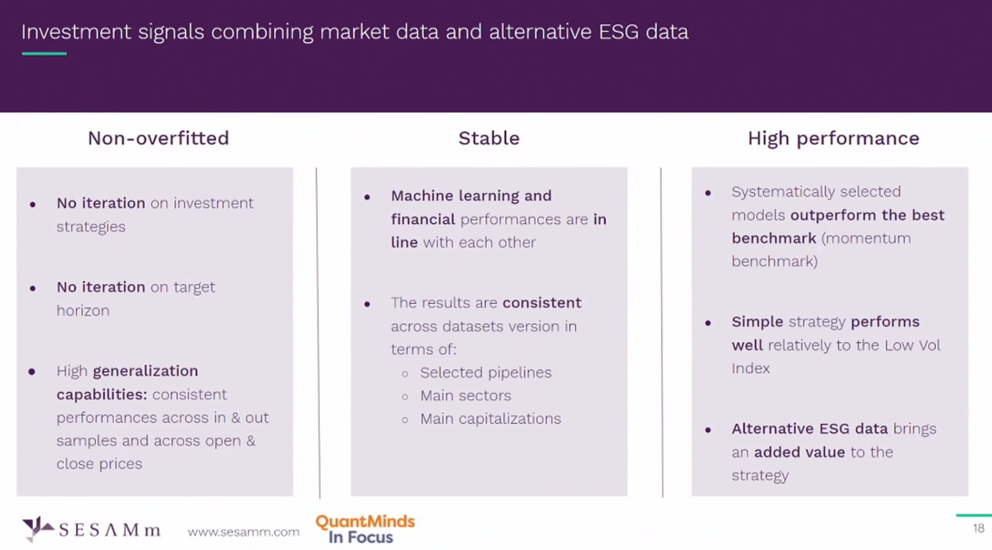

# New developments in Deep Pricing

* Youssef Elouerkhaoui

3 formulations :

* Deep Pricer
* Deep Regressor (for American Monte Carlo)
* Deep Solver : solve pricing PDE

All share similar challenge: how de control approx error in high dimensional spaces.

Goal : Understanding geometry of DL models : Benefits:

1. Build better model
2. Provide “bottom-up” explanation of the model output

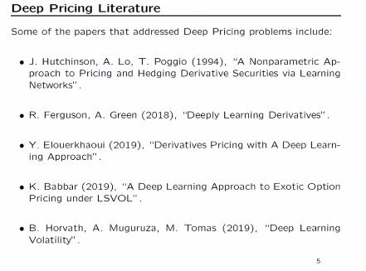

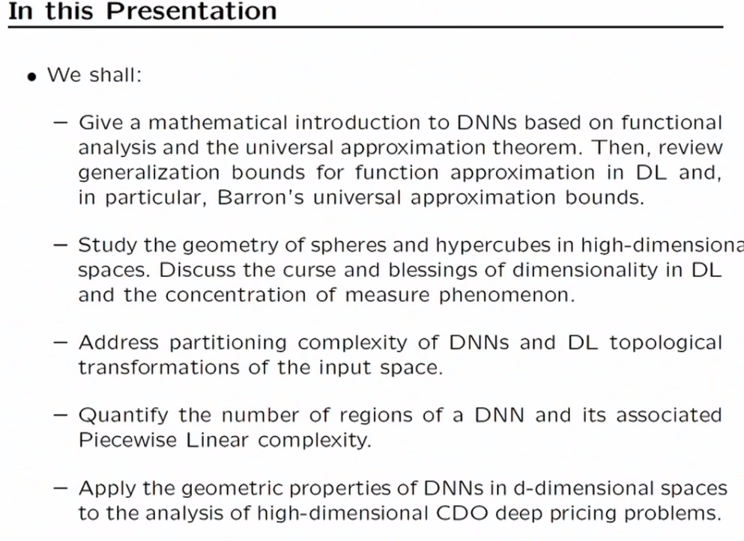

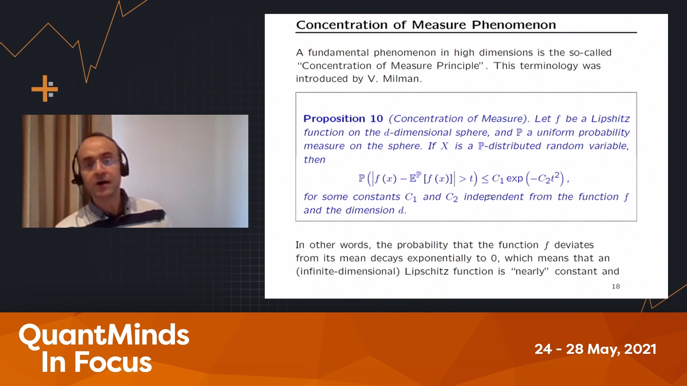

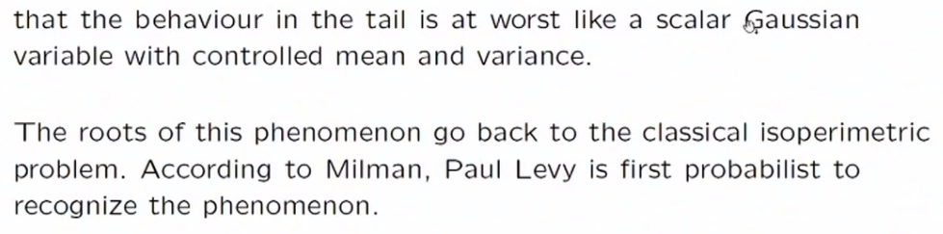

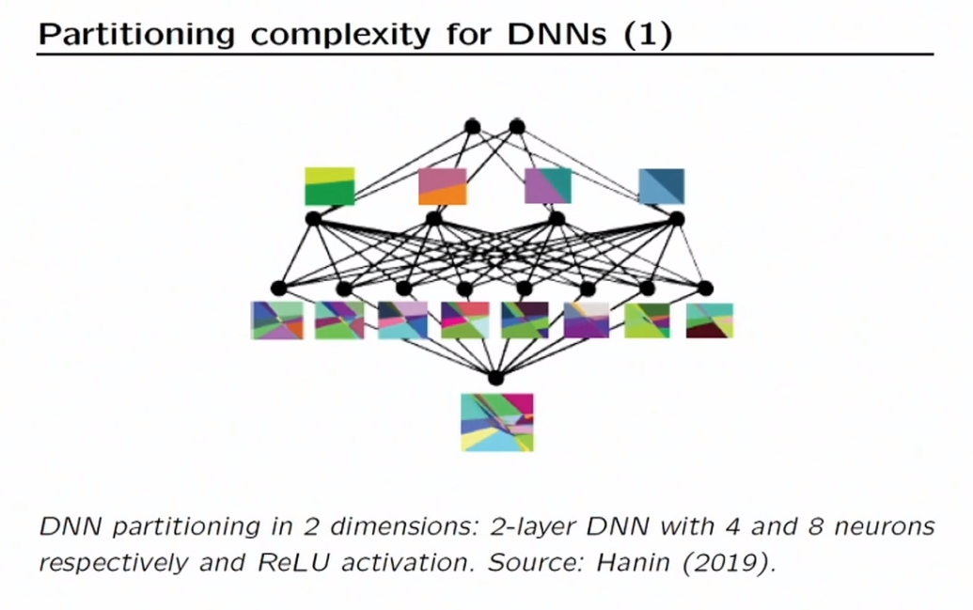

Hanin :

Deep ReLU Networks Have Surprisingly Few Activation Pattern

<https://arxiv.org/pdf/1906.00904.pdf>

Complexity of Linear Regions in Deep Networks

<https://arxiv.org/pdf/1901.09021.pdf>

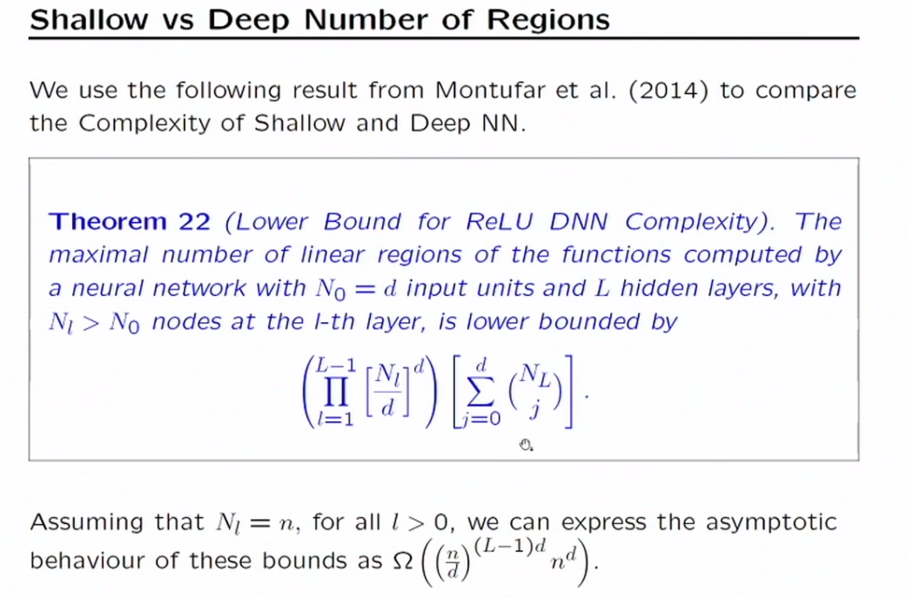

# **On the Number of Linear Regions of Deep Neural Networks**

<https://arxiv.org/abs/1402.1869>

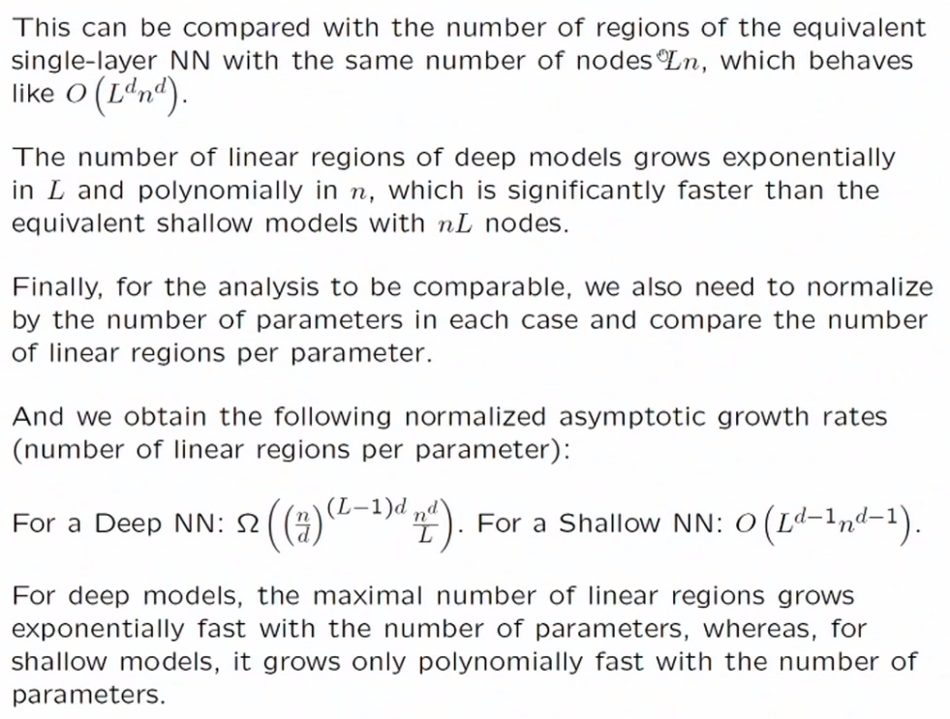

# Valuing Exotic Options and Estimating Model Risk

* Jay Cao, Jacky Chen, John Hull and Zissis Poulos

Yes this is about machine learning 😊

“like a lot of you I’v moved from traditionnal quantitative finance into machine learning in the last few years”

“all of my teaching is in the machine learning area”

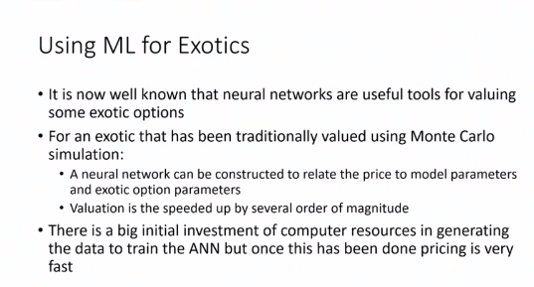

Speeding up exotic evaluation :

1. Create a lot of data (BIG initial time consumption)
2. Use a NN model to valuate (Once done, several order of magnitude faster)

**Model calibration Approach : MCA**

1. Choose model
2. Look a volatility surface
3. Fit Vol surface to model
4. Price Exotic

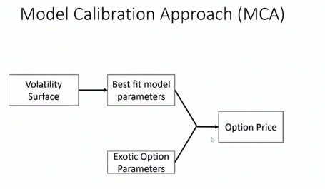

Problem ? We loose information about the volatility surface … Ex : fit with equal weight... but some points are more important... and we should give them more weight (but we don’t know which)

**Volatility Feature Approch (VFA)**

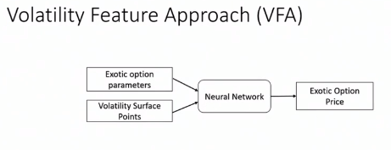

There is a model... **but its parameter are not inputs of NN, instead all point of the “vol surface” are.**

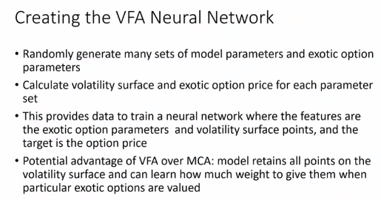

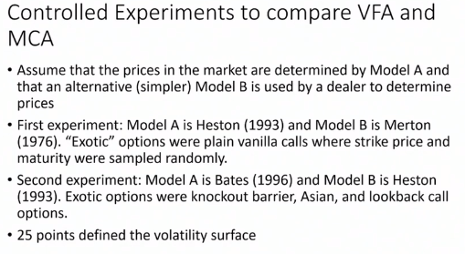

**=> VFA’s performance relative to MCA improves as calibration error increases**

When calibration error is really low MCA is better, but when callibration error is higher VFA’s is better

Calibration Error = quality of FIT of vol surface

**2nd part of talk : model error ?**

Example : VFA with Bates and Rough Vol (Jaber) : exploring difference is a good way to gauge model risk.

Sensitivity Analysis: do the NN really learn to weight volatility surface differently depending on the exotic option that is priced ?

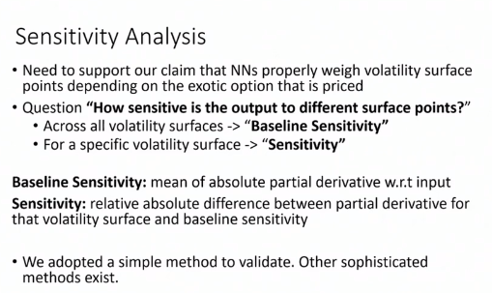

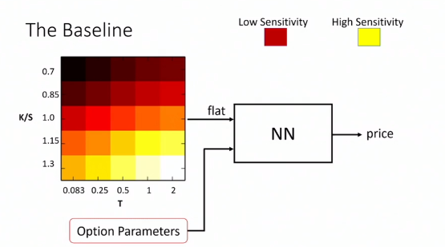

Imbalanced : some point have ONE average more importance than other

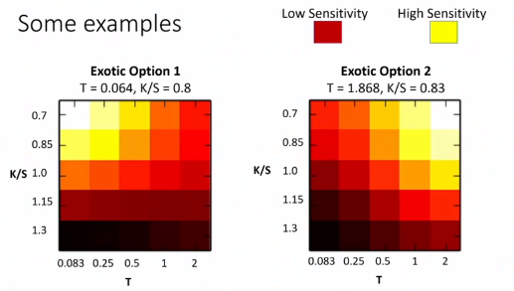

==> highlight on point close to relevant part of vol surface

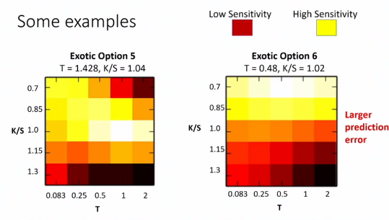

Option 6 : NN is doing a bad job (large prediction error)… and it’s looking at the wrong place.

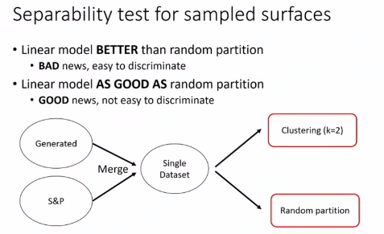

We want to look if our generated data is “close” to real S&P data. By trying to separate using KMeans (linear model)

If the algo can’t differentiate... it tells us that our data are rich enough to encapsuldate real data... And it means that our NN won’t have to extrapolate too much.

Can help refine the process of generating data.

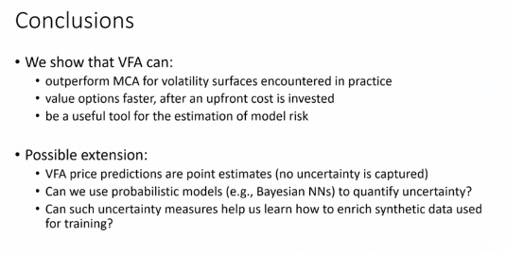

# Next Generation in local volatility

* Jesper Andreasen
* Kwant Father
* Saxo Bank

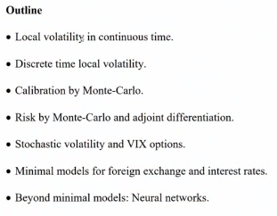

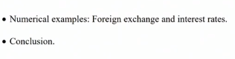

Local vol recap :

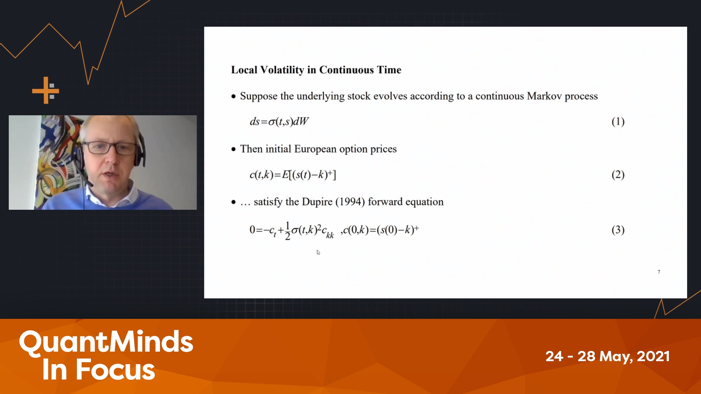

=> Beautiful maths, but not very praticle.

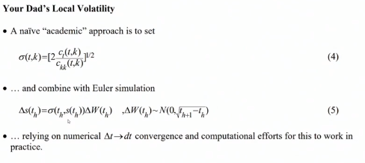

So you assume you have enough timestep so that it’s correct. But :

* Interpolation / extrpolation in (4) ?
* Finit difference (expplicite, implicite,…) ?
* How small Dt ?
* ….

In discrete time :

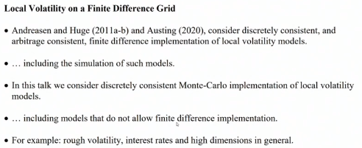

(Ex : ‘rough vol’ : non markovian)

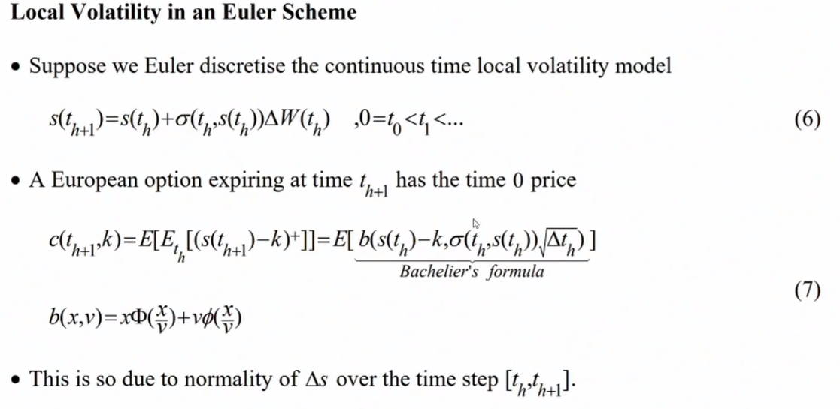

Calibration, vega,… easy

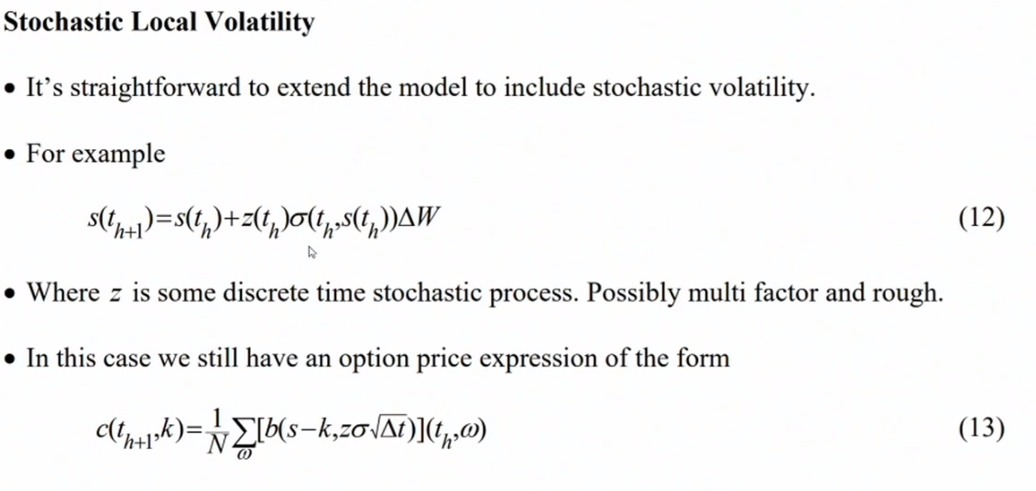

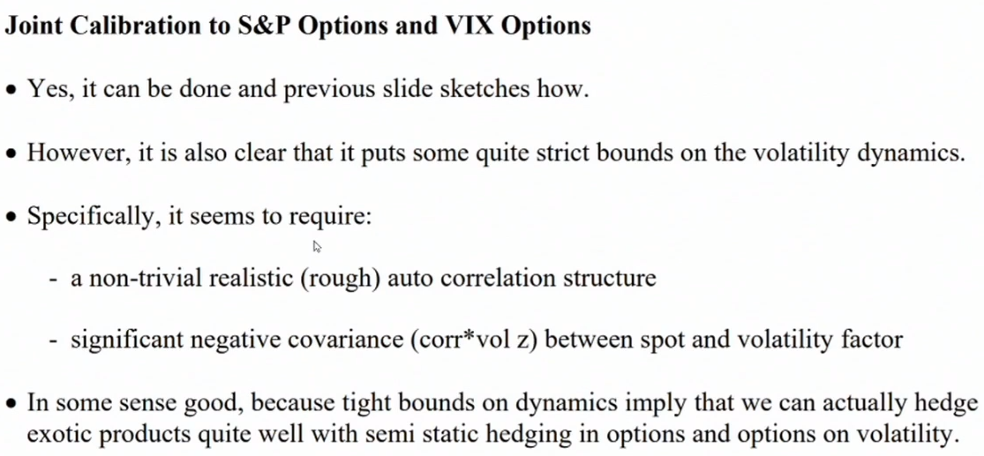

To Caliber VIX option and S&P option in the same model... can be done but impose lots of structure (which is not bad per see)

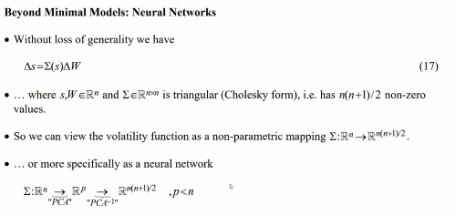

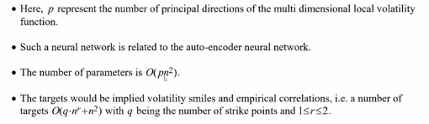

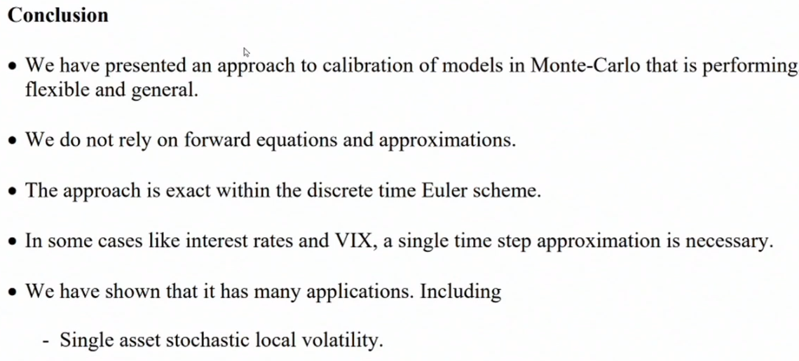

# Trading and hedging bitcoin and crypto asset volatility

* Carol Alexander (Sussex University)

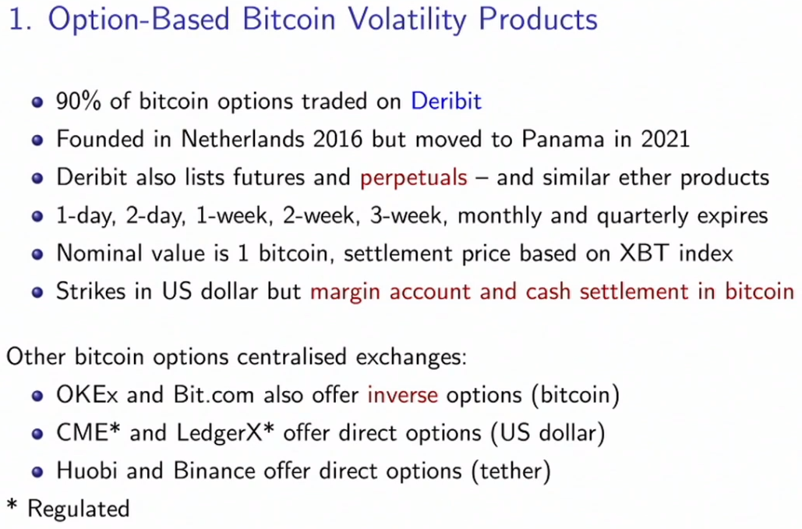

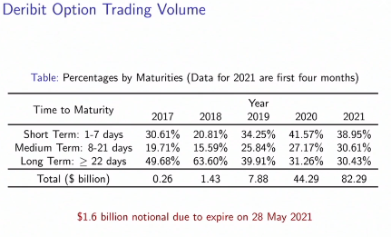

* Bitcoin like currency (relatively flat vol surface)
* Other crypto behave like commo, stocks, bonds..

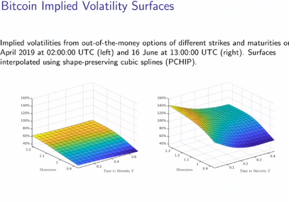

=> bitcoin variance swap are traded.

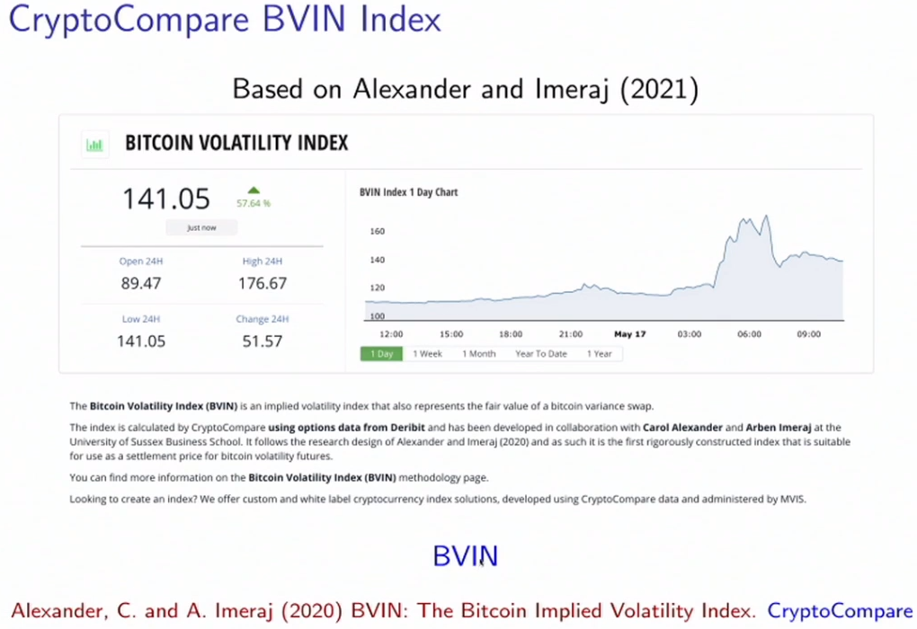

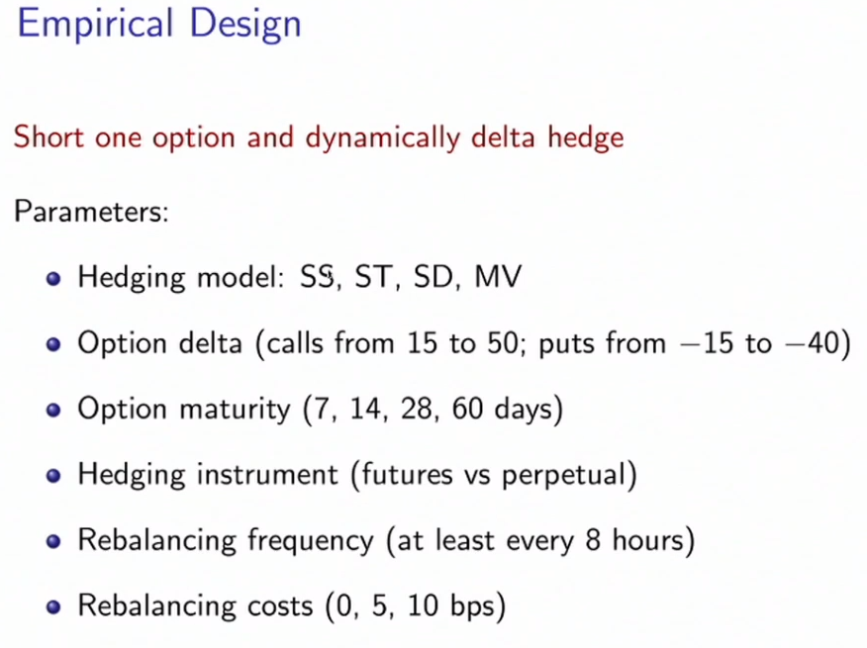

How to hedge bitcoin option ?

Difference if we considere payoff directly in bitcoin (instead of USD)

# Asymetric Greeks and Application

* Nadhem Meziou (Natixis)

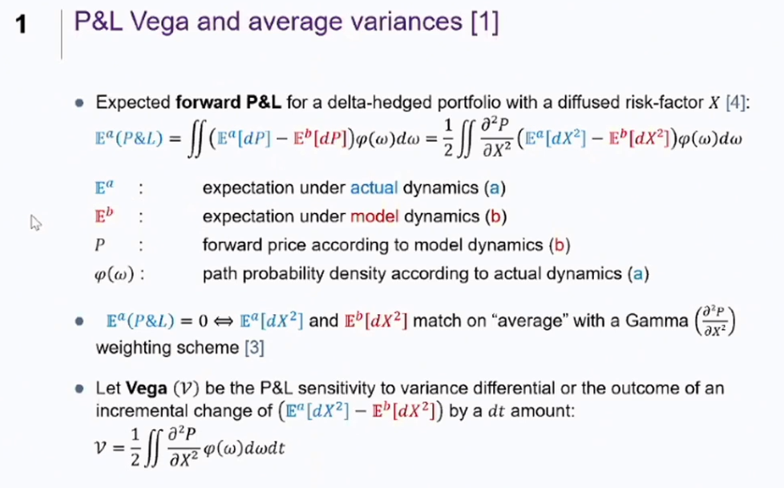

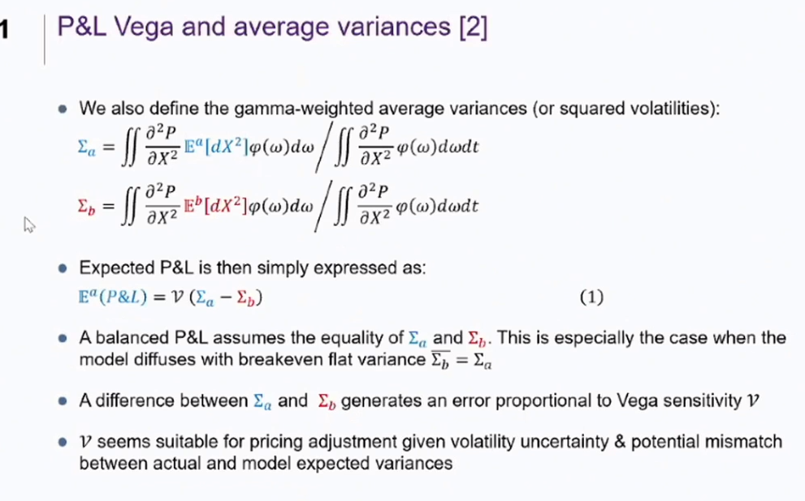

We had an issue because averaging positiv; negativ ...

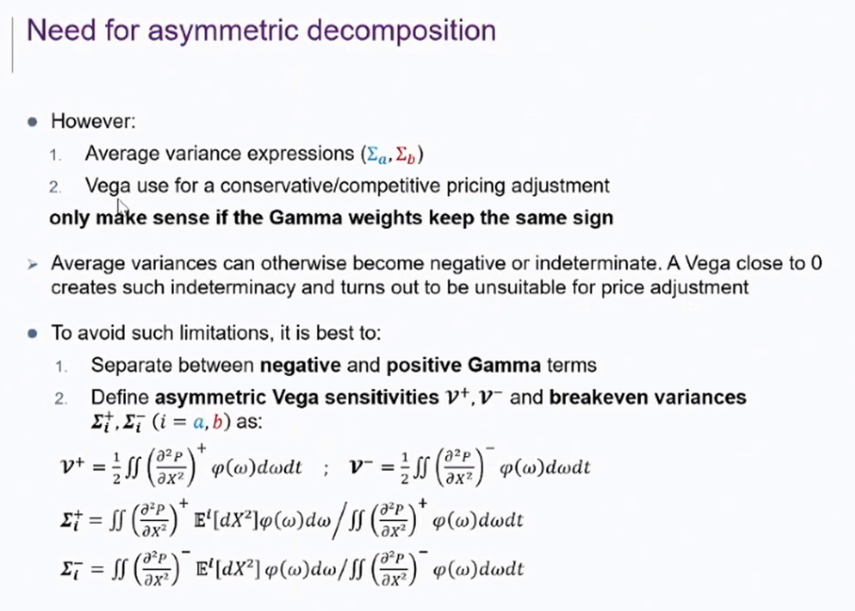

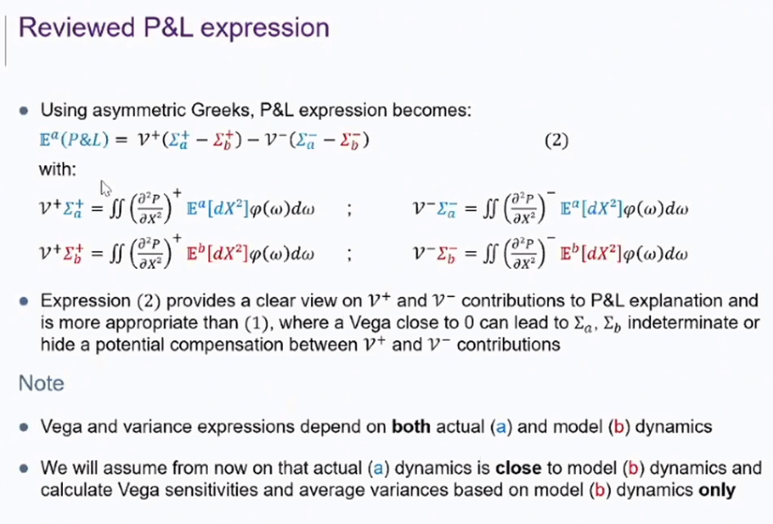

* contribution off positiv/negativ gamma.
* Well defined term

Adjustement to payoffs... allow pricing of those asymetric greeks. (???)

Hedge :

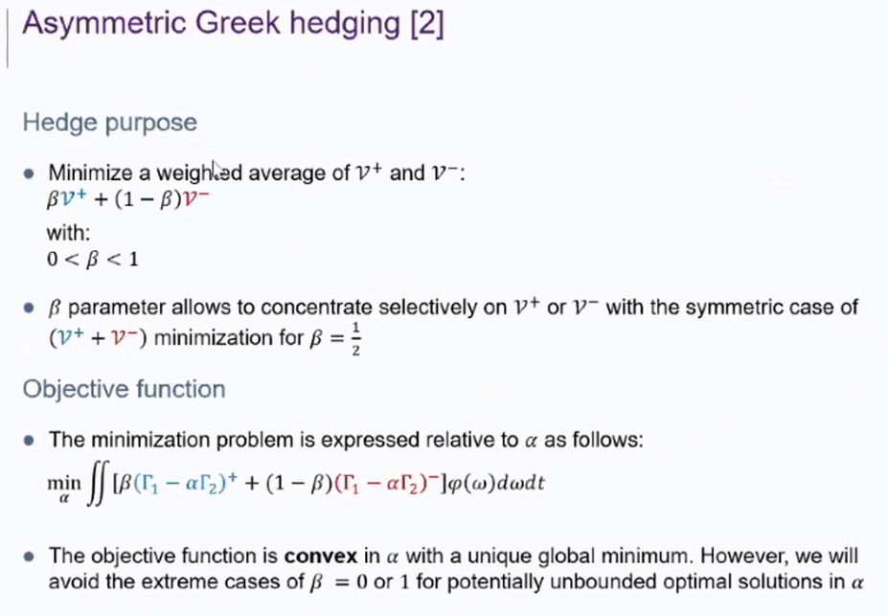

Other asymetrics :

* Funding cost : depend on sign of pnl
* CVA/DVA : credit risk depends on sign also

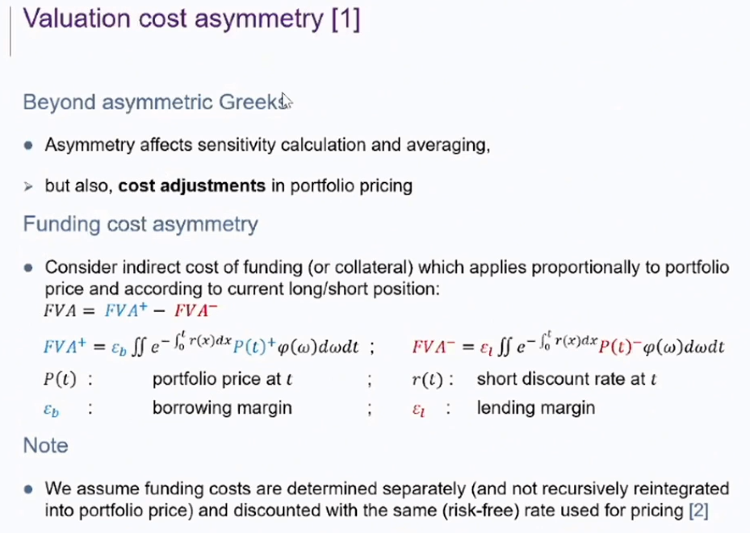

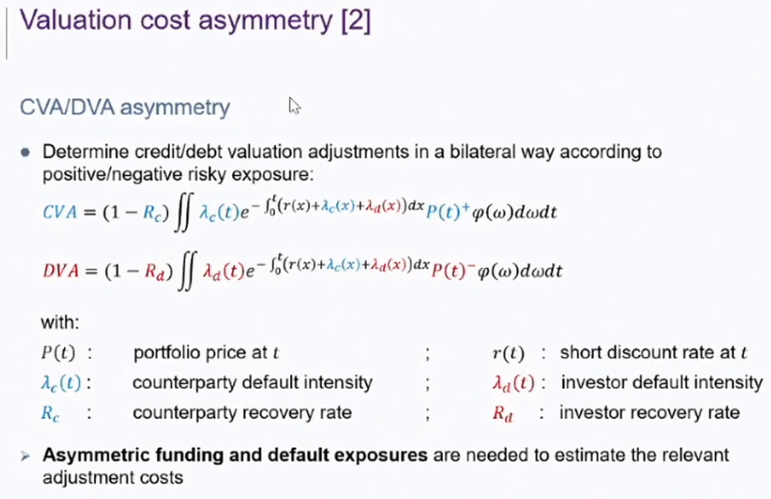3

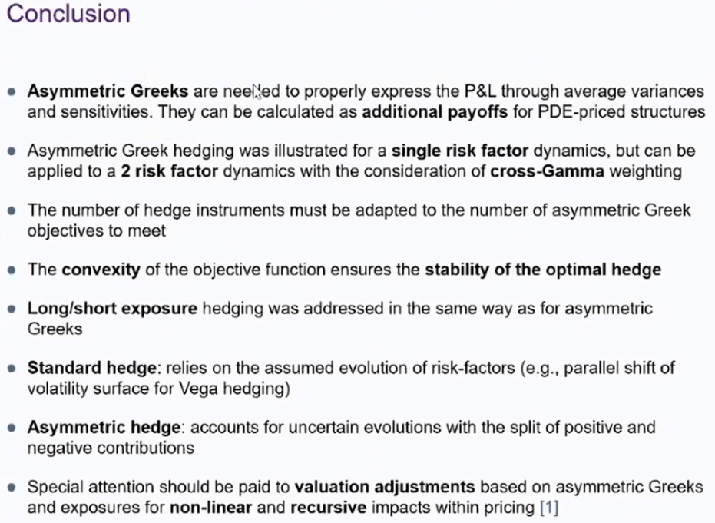

# High Performance Computing in the financial Industry : Algorithmic investment and trading

* Erik Vynckier

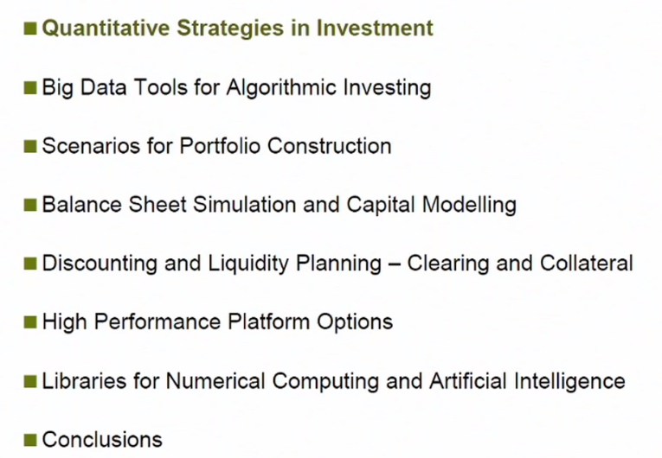

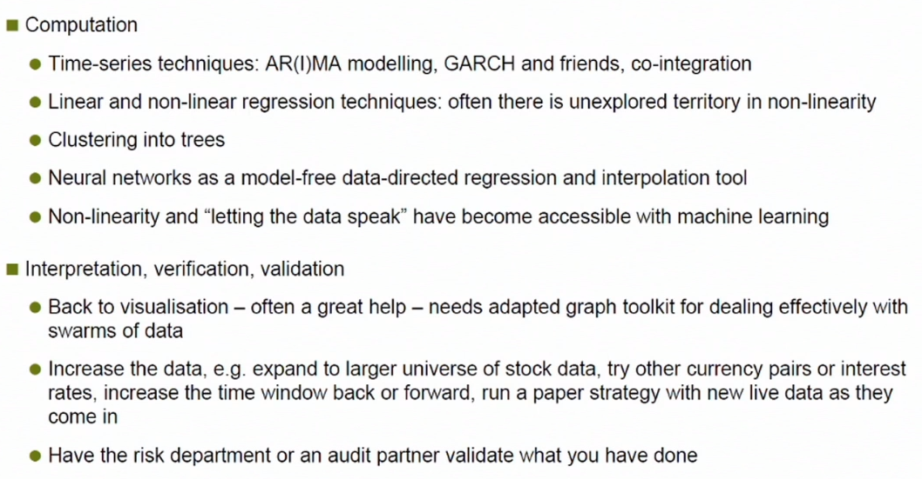

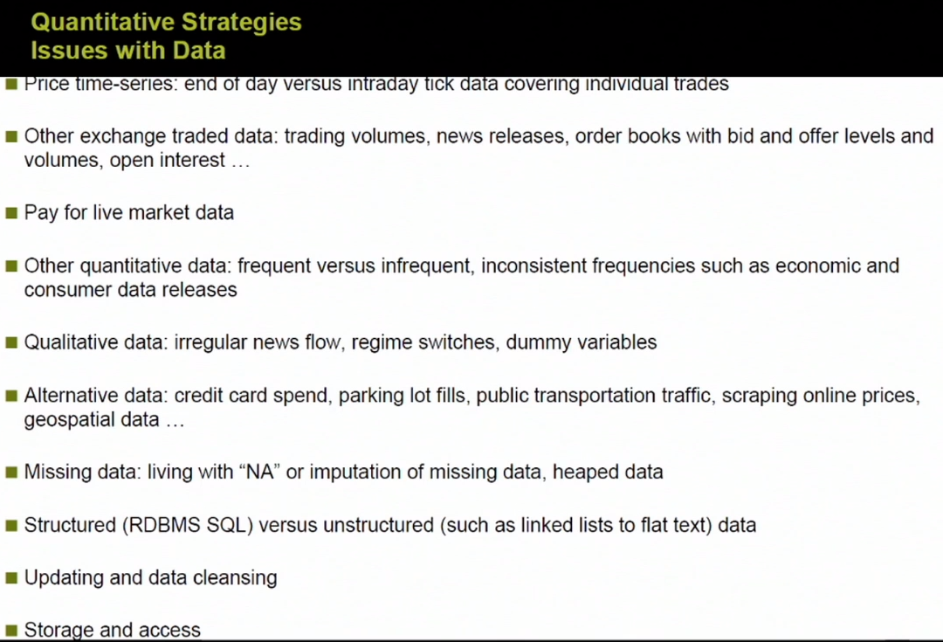

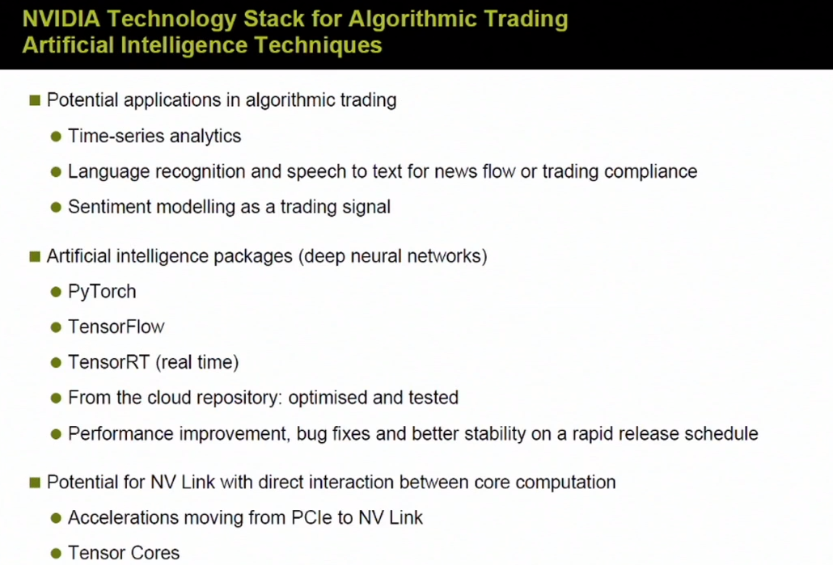

# Latest developments of differential machine learning

* Antoine Savine (Danx bank)
* “Millions of AAD are computed everyday” ==> those can be used.

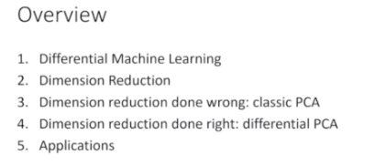

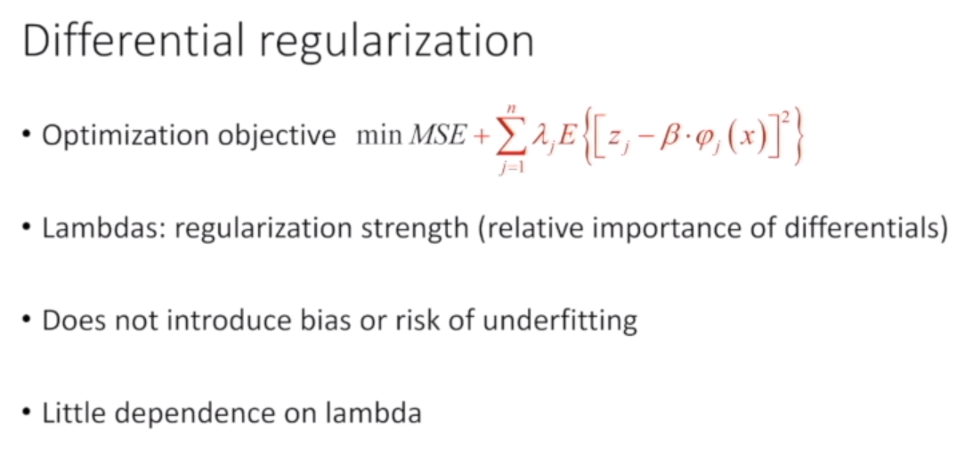

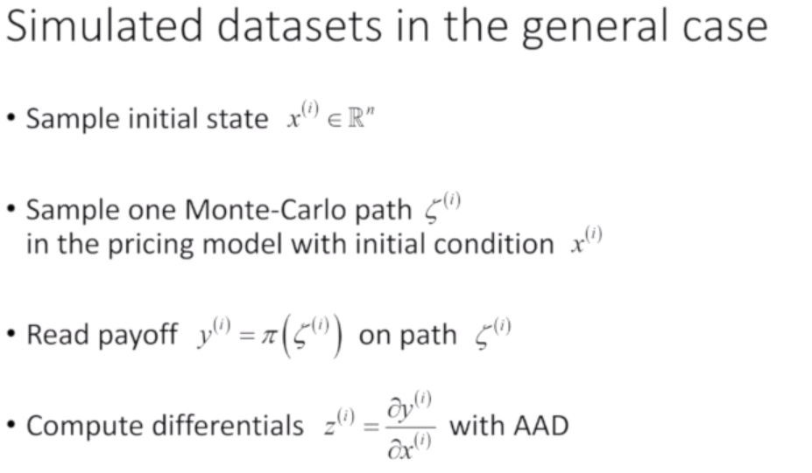

=> we need to have ‘AAD’ on our MC engine.

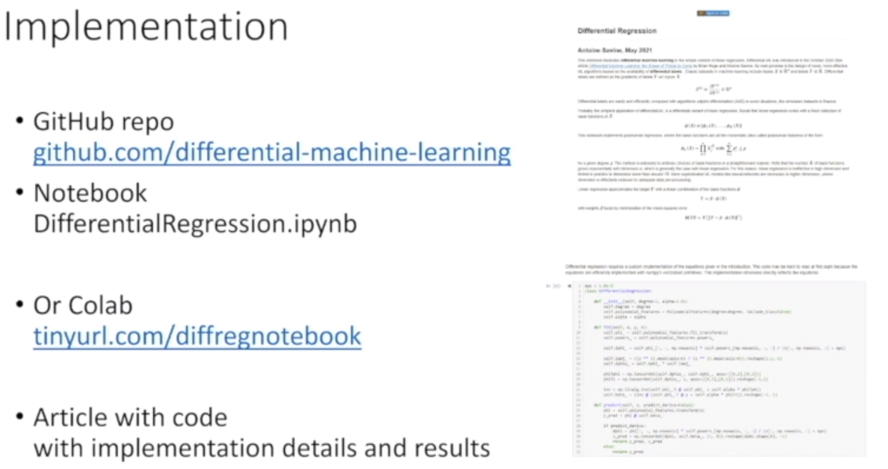

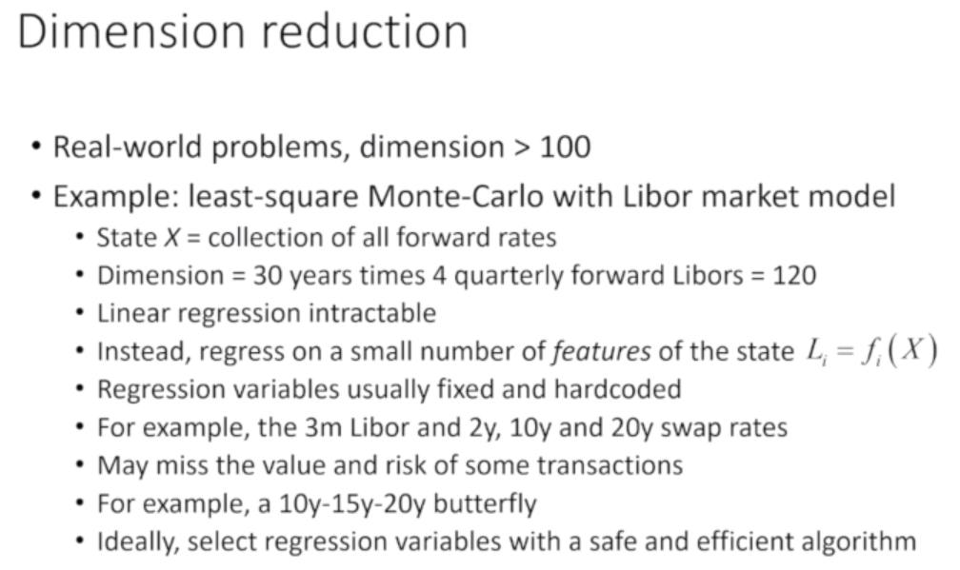

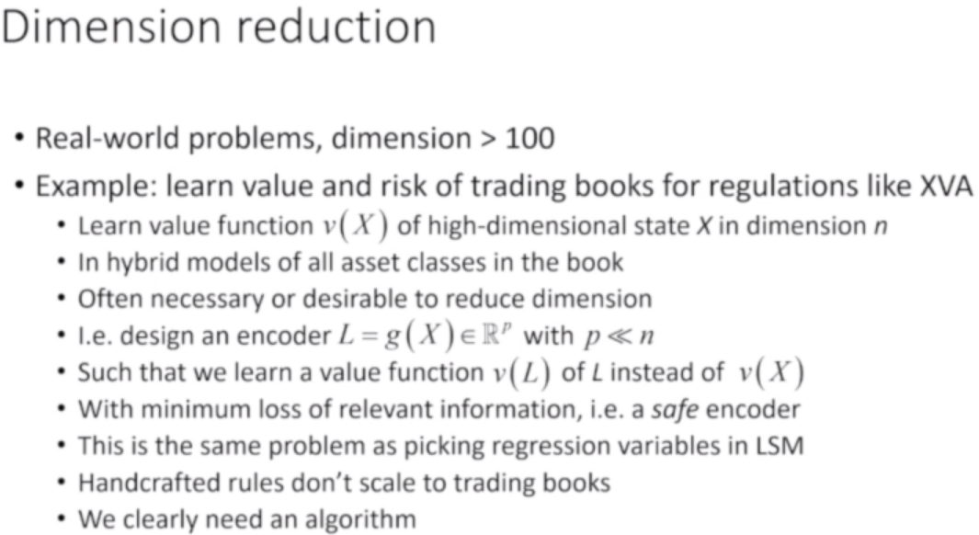

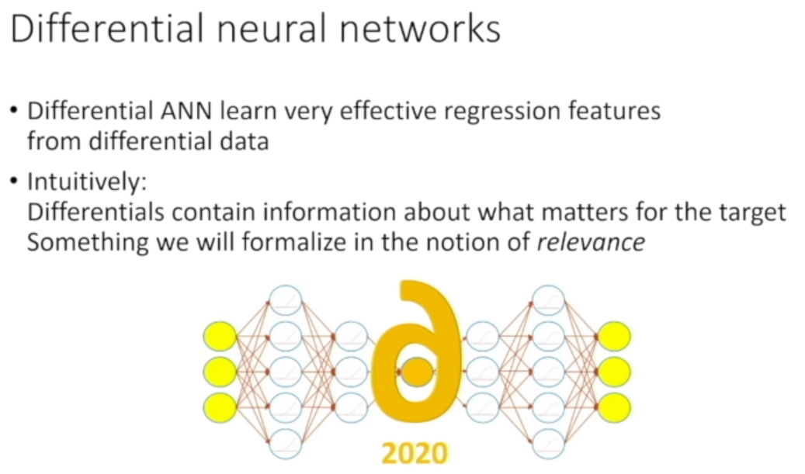

* Regular PCA : not adapted for risk

PCA focus on reconstruction error... not adapted.

Here I want to know how something depends on the axes... : PCA can align axis to what matter... and completly drop relevant information sometimes

=> we would like to projet on axes where magnitude of gradient is MAX

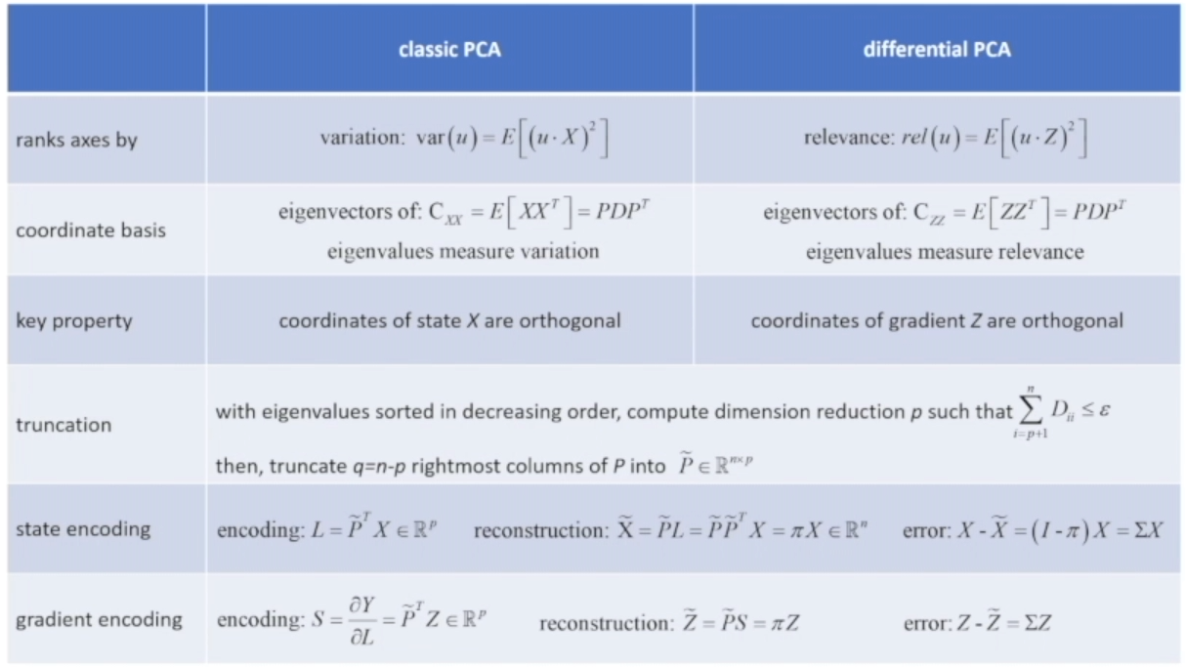

Algo is close, but transformation is very different

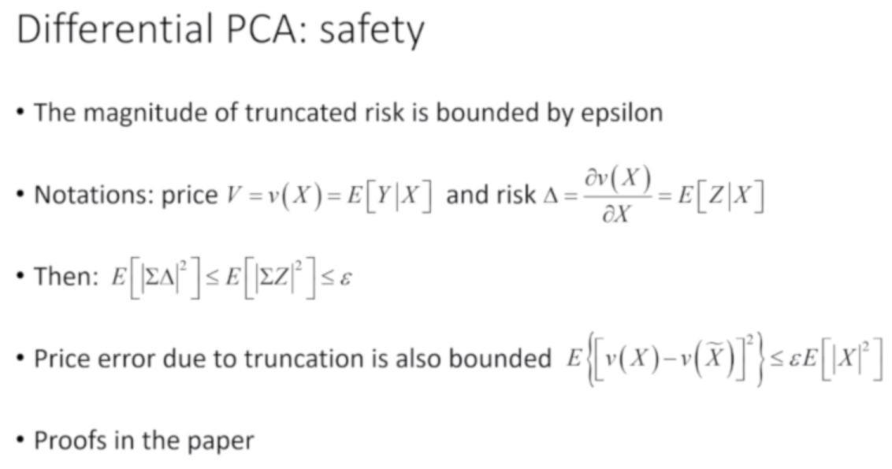

=> small error on price : safe

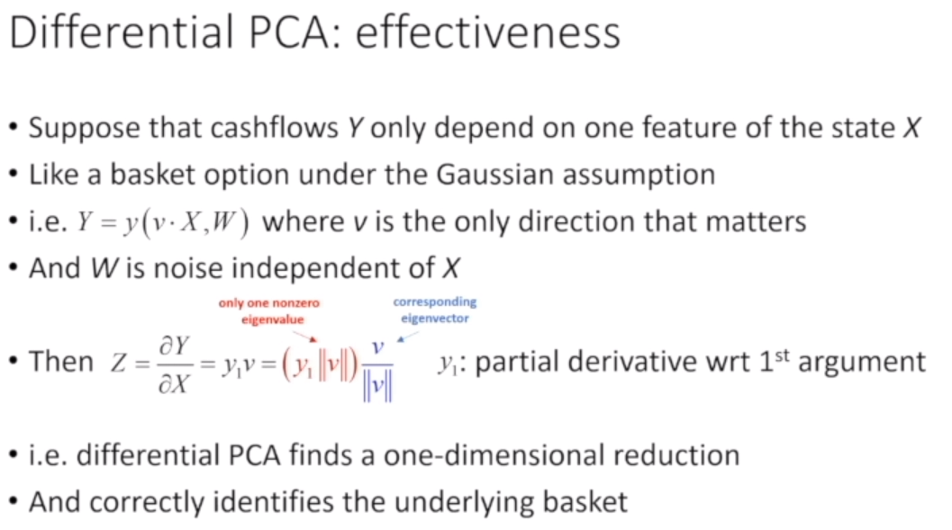

=> correctly find axes

